Stone Nettles
Assignment 4.2
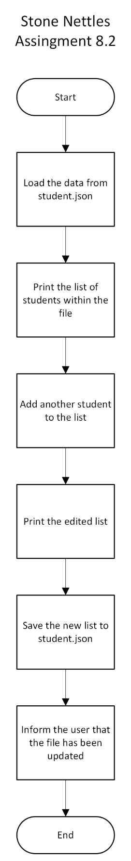
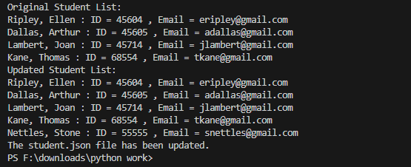

I did not see the notification that the file had changed and do not know why. I used VS Code for my assignment and checked to make sure that the file actually got updated after running my code.

{
"F_Name": "Ellen",
"L_Name": "Ripley",
"Student_ID": 45604,
"Email": "eripley@gmail.com"
},
{
"F_Name": "Arthur",
"L_Name": "Dallas",
"Student_ID": 45605,
"Email": "adallas@gmail.com"
},
{
"F_Name": "Joan",
"L_Name": "Lambert",
"Student_ID": 45714,
"Email": "jlambert@gmail.com"
},
{
"F_Name": "Thomas",
"L_Name": "Kane",
"Student_ID": 68554,
"Email": "tkane@gmail.com"
},
{
"F_Name": "Stone",
"L_Name": "Nettles",
"Student_ID": 55555,
"Email": "snettles@gmail.com"
}
]

